# Industrial Training Report

## (July 2021 – September 2021)

**General Awareness of Steam Turbine Manufacturing**

Submitted in partial fulfilment of the requirements of the Degree of Integrated B-tech+ M-tech (Mechanical Engineering)

By

**ABHISHEK KUMAR**

(Reg No – 202100190)

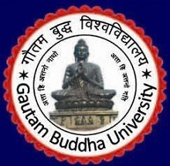

**GAUTAM BUDDHA UNIVERSITY**

(201312)